**Semester 1 (Unit 3) Examination, 2019**

**Question/Answer Booklet**

**MATHEMATICS METHODS**

**Section Two: Calculator-assumed**

Student Name/Number: ______________________________________________

Teacher Name: ______________________________________________

**Time allowed for this section**

Reading time before commencing work: ten minutes

Working time for this section: one hundred minutes

**Materials required/recommended for this section**

**To be provided by the supervisor:** This Question/Answer Booklet

Formula Sheet

**To be provided by the candidate:**

Standard items: pens (blue/black preferred), pencils (including coloured), sharpener,

correction fluid/tape, eraser, ruler, highlighters

Special items: drawing instruments, templates, notes on two unfolded sheets of A4 paper, and up to three calculators approved for use in this examination

**Important note to candidates**

No other items may be taken into the examination room. It is **your** responsibility to ensure that you do not have any unauthorised notes or other items of a non-personal nature in the examination room. If you have any unauthorised material with you, hand it to the supervisor **before** reading any further.

**Structure of this paper**

|  |  |  |  |  |  |
| --- | --- | --- | --- | --- | --- |
| Section | Number of questions available | Number of questions to be answered | Working time (minutes) | Marks available | Percentage of exam |
| Section One: Calculator-free | 7 | 7 | 50 | 50 | 35 |
| Section Two: Calculator-assumed | 13 | 13 | 100 | 100 | 65 |
|  | | | | | 100 |

**Instructions to candidates**

1. The rules for the conduct of School exams are detailed in the School/College assessment policy. Sitting this examination implies that you agree to abide by these rules.
2. Write your answers in this Question/Answer booklet preferably using a blue/black pen. Do not use erasable or gel pens.
3. You must be careful to confine your answer to the specific question asked and to follow any instructions that are specified to a particular question.
4. Show all your working clearly. Your working should be in sufficient detail to allow your answers to be checked readily and for marks to be awarded for reasoning. Incorrect answers given without supporting reasoning cannot be allocated any marks. For any question or part question worth more than two marks, valid working or justification is required to receive full marks. If you repeat any question, ensure that you cancel the answer you do not wish to have marked.
5. It is recommended that you do not use pencil, except in diagrams.
6. Supplementary pages for planning/continuing your answers to questions are provided at the end of this Question/Answer booklet. If you use these pages to continue an answer, indicate at the original answer where the answer is continued, i.e. give the page number.
7. The Formula sheet is not to be handed in with your Question/Answer booklet.

**Section Two: Calculator-assumed 65% (100 Marks)**

This section has **13** questions. Answer **all** questions. Write your answers in the spaces provided.

Supplementary pages for planning/continuing your answers to questions are provided at the end of this Question/Answer booklet. If you use these pages to continue an answer, indicate at the original answer where the answer is continued, i.e. give the page number.

Suggested working time: **100 minutes**

**Question 8 (7 marks)**

(a) Given that ,

(i) evaluate  (1 mark)

(ii) evaluate  (3 marks)

(b) Determine exactly,. (3 marks)

**Question 9 (8 marks)**

The quartic function  has the following properties

* 
*  and
* 

(a) Is  positive or negative? Justify your answer. (1 mark)

(b) Determine the *x* coordinates of the stationary points of  (1 mark)

(c) Show that  has a horizontal point of inflection where  and state the value

of  (3 marks)

(d) sketch the function  on the axes below, clearly labelling all key features.

(3 marks)

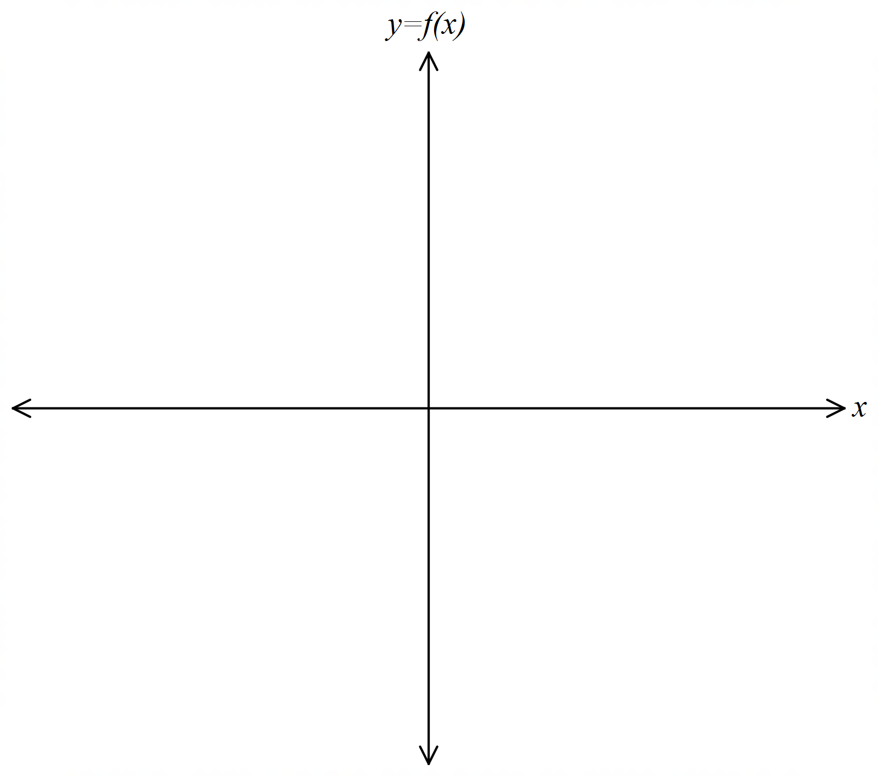

**Question 10 (10 marks)**

A fair coin is tossed $n$ times. and the number of heads that appear, is counted. Let $X$ denote this number.

(a) Describe the distribution of $X.$ (1 mark)

(b) What is the expected number of heads that will appear? (1 mark)

Let $P_{1}$  denote the probability that the number of heads that appear differs from the expected value by at most $5$.

(c) Use your calculator to estimate $P_{1}$  if $n=20, n=1000$ and $n=10 000$. (3 marks)

(d) What happens to $P_{1}$ as  becomes very large? (You don’t have to prove your claim.)

(1 mark)

Let $P_{2}$  denote the probability that the number of heads that appear differs from the expected value by at most $5\%$ of the expected value.

(e) Use your calculator to estimate $P_{2}$  if $n=20, n=200$ and $n=1000$. (3 marks)

(f) What happens to $P_{2}$ as n becomes very large? (You don’t have to prove your claim.)

(1 mark)

**Question 11 (8 marks)**

A ball is dropped from 30 metres above ground level off a balcony. The vertical distance the ball has fallen,  measured in metres  seconds after it has been dropped has been modelled by the equation  where  is a constant and 

1. Evaluate  (1 mark)
2. At what speed is the ball travelling when it hits the ground? (3 marks)
3. Is the ball slowing down, speeding up or maintaining constant velocity as it hits the

ground? Justify your answer with calculus. (2 marks)

1. According to this model, as  what happens to the speed of the ball? (1 mark)
2. In light of part (d) above, how could this model be improved? (1 mark)

**Question 12 (6 marks)**

A large mathematics class in a particular school is split into two groups and the groups take different tests. In the first group there are 49 students, their mean score is 63.3 and the standard deviation of their scores is 7.6. There are 38 students in the second group, their mean score is 54.1 and the standard deviation is 10.2.

(a) Calculate $μ$, the mean of the complete set of test scores. (2 marks)

It is decided to scale both sets of scores using linear transformations of the form

$$Y=aX+b$$

where $X$ is any unscaled score and $Y$ is the corresponding scaled score, and $a$ and $b$ are constants.

After scaling, the mean score of each of the two sets of scores equals $μ$, and the standard deviation of each set of scores is 9.

(b) Determine the constants $a$ and $b$ that will be used to scale the first set of scores.

(4 marks)

**Question 13 (10 marks)**

(a) The graph of a function has a gradient given by  and has a local maximum of 1.

Show how to use the second derivative test to determine the *x*-coordinate of the maximum at and hence determine the equation of the function.

. (5 marks)

(b) A manufacturing company produces coffee cups in two different sizes, A and B. Both cups are in the shape ofa truncated, right, circular cone as shown below. Both have a height,  , of 15 centimetres and have a base radius of 3 centimetres. Cup B is smaller than cup A.

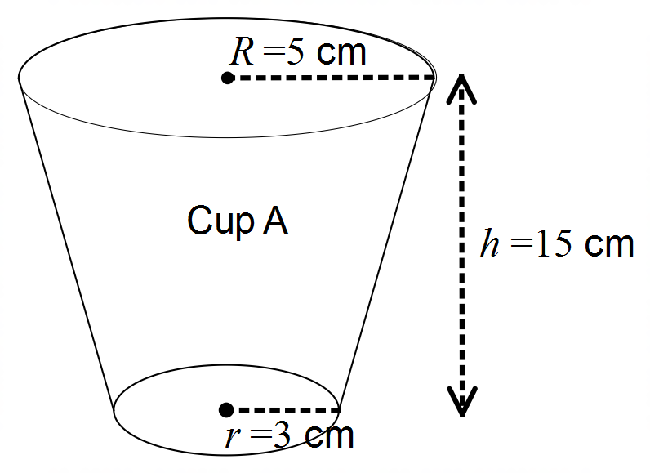

The formula for the volume,  of such a shape is given by

 where  perpendicular height,  upper radius of the cup and  the base radius of the cup.

(i) Calculate the volume, to the nearest cubic centimetre, of cup A which has an upper radius of 5 cm. (1 mark)

(ii) Use the incremental formula to determine the difference in capacity of the two cups if cup B has an upper radius of 4.8 centimetres. (4 marks)

**Question 14 (10 marks)**

To help relieve the monotony of a long car journey the children in the back seat decide to play ‘Spotto’. They do this by noting the colour of cars travelling in the opposite direction. In a trial period they observe the following numbers of cars of various colours:

|  |  |  |  |  |
| --- | --- | --- | --- | --- |
| White | Black | Red | Blue | Other |
| 27 | 13 | 11 | 4 | 14 |

You may assume that this particular distribution of car colours is typical, and that car colours are randomly distributed.

(a) Use the data above to estimate the probabilities of the colour of the next car to come along. Since the sample is small, these estimates will not be reliable, so make your estimates whole multiples of $0.05.$ (3 marks)

The children collect points for each car of a particular colour that they spot. The following table shows the colours allocated to the various children and the points value of each spotted car of a particular colour.

|  |  |  |  |  |
| --- | --- | --- | --- | --- |
| Willie | Belinda | Rodney | Barbara | Odele |
| White | Black | Red | Blue | Other |
| 2 | 4 | 7 | 9 | 5 |

(b) Estimate the expected number of points that will be collected if $100$ cars are spotted.

(3 marks)

(c) Who is most likely to accumulate the most points in the long run? (2 marks)

(d) Estimate the probability that the next two cars will be in the same colour category.

(2 marks)

**Question 15 (8 marks)**

(a) For each of the situations below, decide whether the answer could be obtained using a binomial distribution, a Bernoulli distribution, a discrete uniform distribution or none of those distributions.

(i) It is known that 11 students out of a group of 25 students are international. Determine the probability that if two students are selected, both are international students. Assume the selection is random. (1 mark)

(ii) The discrete random variable,  is such that  for 

Determine the probability distribution of  (1 mark)

(iii) A fair eight-sided die is rolled 100 times. Calculate the probability of obtaining more than 61 odd scores. (1 mark)

(iv) In a very large population of students, 23% are known to be international students. If 25 students are selected, determine the probability that exactly 9 students are international. Assume the selection is random.

(1 mark)

(b) Which of the following functions,  could represent a discrete probability function for the random variable,  Justify your answer.

1.  where  (2 marks)

|  |  |  |  |  |
| --- | --- | --- | --- | --- |
|  | 4 | 6 | 8 | 10 |
|  | 0.05 | 0.30 | 0.25 | 0.4 |



(2 marks)

**Question 16 (4 marks)**

The acceleration of a particle, ms-2.

1. Show the displacement, , given that the initial velocity

 and,  where *p* and *q* are real constants. (3 marks)

(b) State an expression to calculate the distance travelled from  to .

(1 mark)

**Question 17 (6 marks)**

The manufacturer of a new type of battery claims that 90% of these new batteries will last 2000 hours or more.

However, a test found that $15$ of a randomly chosen set of 120 of these new batteries lasted less than $2000$ hours.

(a) Assuming the manufacturer’s claim is true calculate the probability that exactly $15$ batteries out of 120 will last less than 2000 hours. (2 marks)

(b) Assuming the manufacturer’s claim is true calculate the probability that no more than 15 batteries will last less than 2000 hours. (2 marks)

(c) Does the test provide compelling evidence that the manufacturer’s claim is false? Give a reason for your answer.

(2 marks)

**Question 18 (8 marks)**

An insurance company offers a ‘death and disability’ policy that pays $50 000 if you die or $10 000 if you are permanently disabled. It makes no other payouts. The company charges a premium of $1000 per year for this benefit. Ignore all other costs incurred by the company.

The death rate per year is estimated to be 1 in every 100 people and another 2 out of every 100 people suffer a permanent disability.

Let the random variable  denote the amount of profit earned in a year by the insurance company from a typical policy. .

(a) Complete the table below

|  |  |  |  |
| --- | --- | --- | --- |
| Outcome | Death | Permanent Disability | No payout |
| Profit earned |  |  |  |
| Probability |  |  |  |

(3 marks)

(b) How much profit can the insurance company expect to make, on average, from each policy that it sells? (2 marks)

(c) Determine the standard deviation of the company’s yearly profit from a typical policy. (3 marks)

**Question 19 (7 marks)**

Consider the graph shown below. The regions bounded by the *x* axis,  and the vertical lines  and  are shaded with lines. The area of each of these regions is indicated by  and the corresponding arrow. The line  intersects the curve at  and  The region  is bounded by the function  and the line  is shaded solidly and indicated with an arrow.

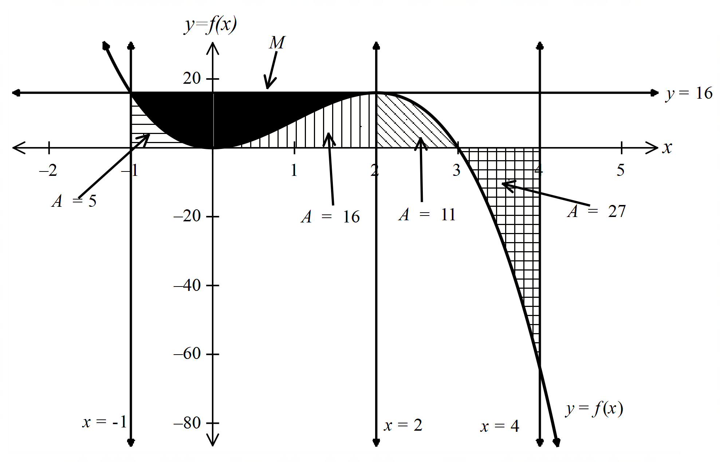



(a) Determine, (1 mark)

(b) Determine,. (1 mark)

(c) Determine the area bounded by the curve and the *x*-axis from  to .

(1 mark)

(d) Determine the area of the shaded region, *M*. (2 marks)

(e) Let  be a constant.

1. Circle the statement that could be true,

 or  (1 mark)

(ii) If  and *k* is an integer, determine the value of *k*. (1 mark)

**Question 20 (8 marks)**

A piece of string is 100 centimetres long. A piece of length  centimetres is cut and used to form a circle. The remaining piece is used to form a square.

(a) Show that the total area of the circle and the square,  is given by

 (3 marks)

(b) Use calculus to determine the value of  that will minimize  (5 marks)

Additional working space

Question number: __________________

Additional working space

Question number: __________________

Additional working space

Question number: __________________

© MAWA, 2019

This examination is Copyright but may be freely used within the school that purchases this licence.

* The items that are contained in this examination are to be used solely in the school for which they are purchased.
* They are not to be shared in any manner with a school which has not purchased their own licence.
* The items and the solutions/marking keys are to be kept confidentially and not copied or made available to anyone who is not a teacher at the school. Teachers may give feedback to students in the form of showing them how the work is marked but students are not to retain a copy of the paper or the marking guide until the agreed release date stipulated in the purchasing agreement/licence.

*Published by The Mathematical Association of WA*

*12 Cobbler Place, MIRRABOOKA 6061*